

**DVT DRIVESTATS**

USER MANUAL



Axel Ind: 12063178

Nick Robinson: 12026442

Zander Boshoff: 12035671

https://github.com/AxelInd/COS301_DriveStats

CLIENT: DVT

Version 2.3

Department of Computer Science. University of Pretoria

Contents

Team: **ANTZ** **Error! Bookmark not defined.**

System Overview 2

System Configuration 2

Minimal Requirements 2

Graphical Illustrations 3

Installation 3

Installation Via the Github Repository 3

Getting Started 3

Before you Begin 3

Google login 4

Layout of system 5

Using the System 6

Android Functionality 6

Start Trip 6

End trip 7

Receiving the trip score 8

Settings 9

View profile 10

View history 11

Troubleshooting 12

Common Problems 12

Contact the Developers 12

Additional Information 12

List of countries currently supported by the DVT DriveStats application 12

Supported Languages 12

# System Overview

DriveStats is a simple road application for Android devices. Its primary purpose is to help users regulate their driving patterns by providing simple feedback on their speed, acceleration, GPS location, and several other key features.

The purpose of this guide is to aid users in their attempts to setup, navigate, and appropriately use the DriveStats Android application.

The DriveStats application provides a range of features for all motorists: from simplistic user-based scoring to tell you exactly how well you are driving, to a fully-featured graphical overview of your driving-patterns, neatly described with graphs.

Collaboration to improve general road safety is a major goal of this product, and, as such, it features a Friend system to allow drivers to share their driving information and compare their safety with friends.

# System Configuration

## Minimal Requirements

To use the DriveStats application a user should possess an Android device with the following features:

1. Android 4.2: JellyBean operating system
2. Wi-fi enabled or 3G enabled
3. GPS capabilities
4. Accelerometer capabilities
5. Google Play Certified[1]

As further requirements for using the DriveStats application a user should have the following:

1. A working Gmail account (required for the initial login)
2. Access to a wi-fi hotspot or other affordable means of internet access
3. A proper dash-mount in their car[2]

## Graphical Illustrations

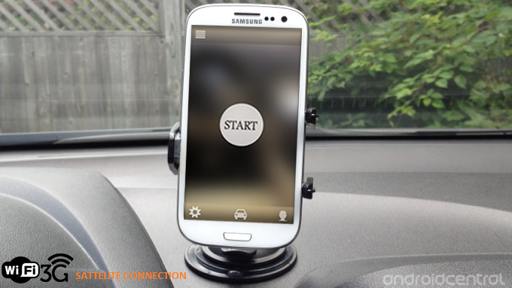

# Installation

## Installation Via the Github Repository

1. Ensure that your smart phone allows third party app installations[3]
2. Navigate to <https://github.com/AxelInd/COS301_DriveStats/apk/>
3. Download the DriveStats.apk file and its associated README
4. Copy the DriveStats.apk file into the download folder of your smart phone
5. Open the file manager on your browser and navigate to the downloads folder
6. Select the APK and select install*

*Image showing selecting our app and clicking install*

At present installation is handled via a compiled apk that is distributed.

\**Your phones security settings must allow for the installation of apps from unknown sources.*

## Getting Started

### Before you Begin

* Ensure that you have the DVT DriveStats Application Installed on your device.
* Ensure that your cellular phone meets the requirements outlined in the Minimal Requirements section.
* Ensure that the device is securely mounted in the vehicle.

### Google login

This is the first screen displayed when the app is ran for the first time. The only option on this screen is to press the G+ sign in button. When this button is pressed, the active network connection (Either a WIFI or a mobile data connection is required for this step) connects with the Google+ service.

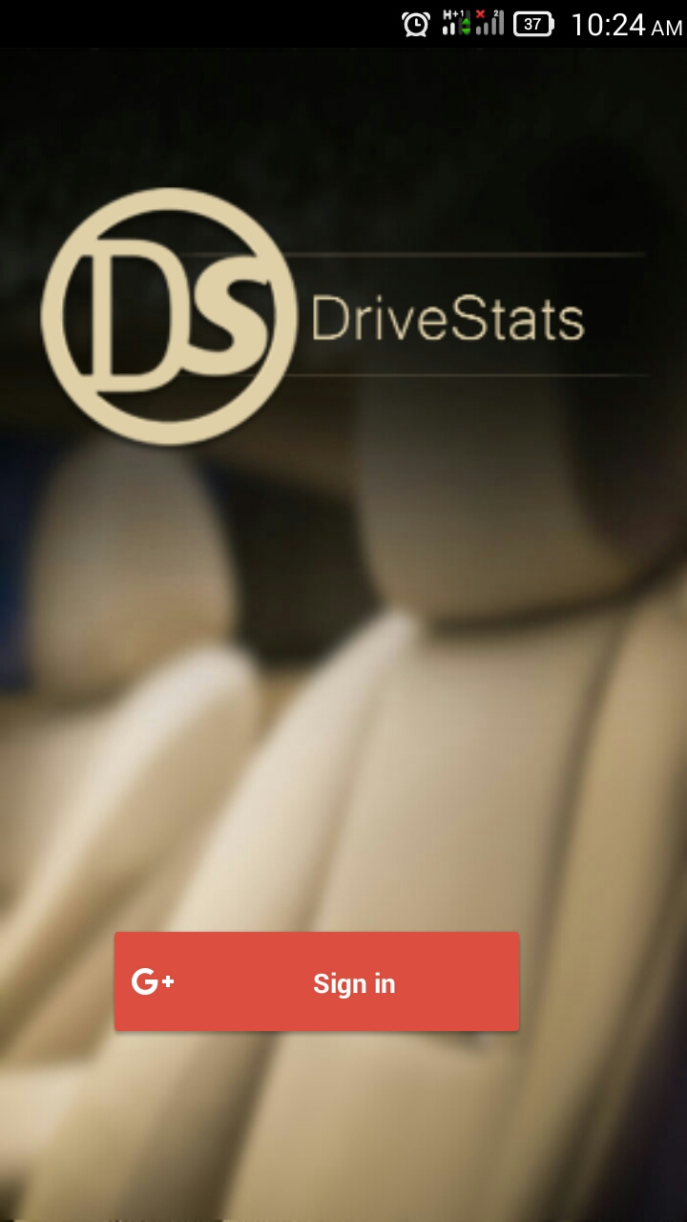

The application will retrieve a list of all the google accounts that are on the phone. One must be chosen to continue the login procedure. The email information linked to the phone is used to authenticate the user. After the user’s information is verified, it is stored on the phone so the user won’t have to log in again.

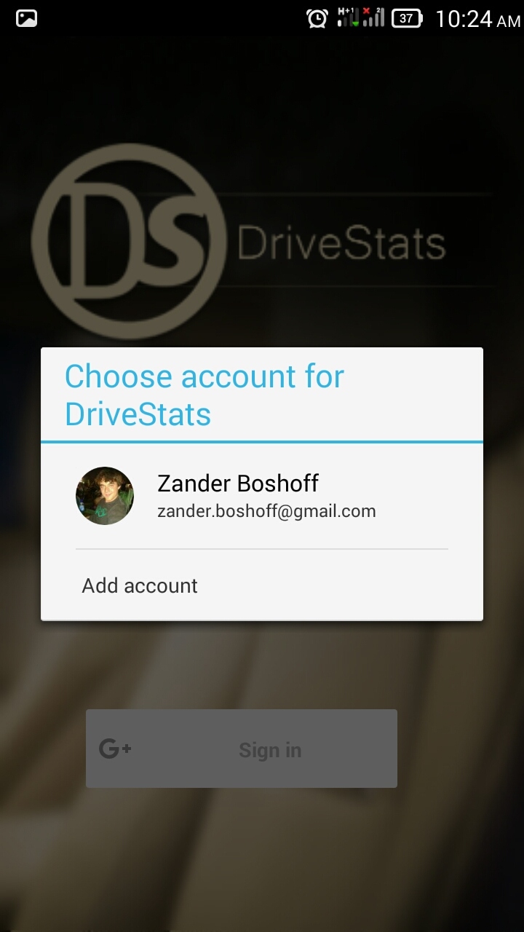

## Layout of system

A visual description of the screens navigation of the app.

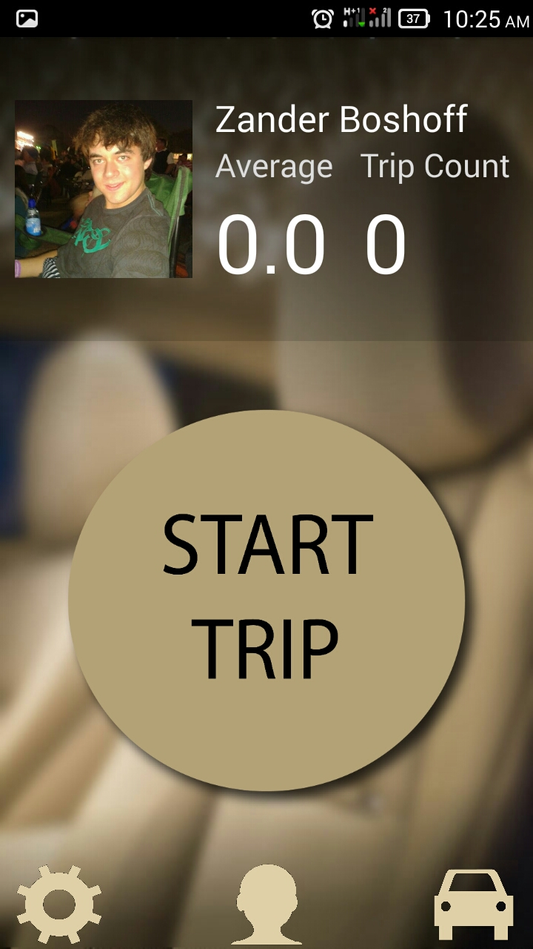

Main Screen

To History

To Profile

To Settings



# Using the System

## Android Functionality

### Start Trip

The DriveStats application requires a user to specify when a trip has started in order to begin collecting data on the driving habits on the user for use in scoring.



**Start Trip**: A toggle button that will cause the application to begin collecting data about the user’s movements.

End trip

When the destination has been reached the stop trip button has to be pushed to stop the phone from gathering further data. The phone will then send the data to the DriveStats server for processing and when it’s done the user will receive a notification with the score of the trip.

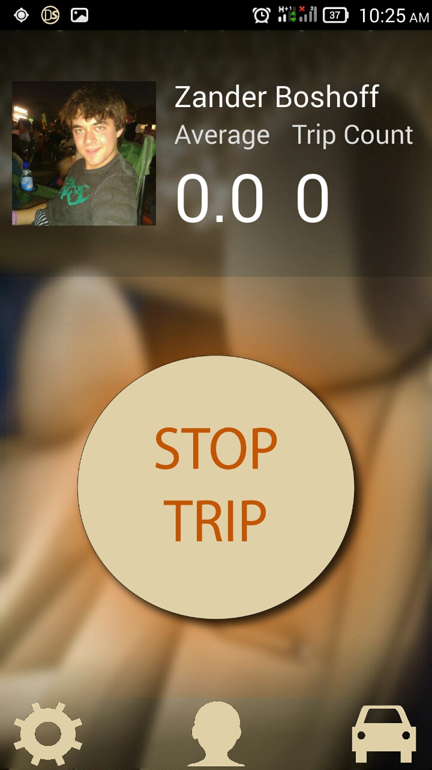

**Stop Trip**: A toggle button that will cause the application to stop collecting data about the user’s movements.

### Receiving the trip score

After the button is toggled the phone will send the trip data to the Drivestats server where a score will be calculated and returned to the phone in the form of a notification.

Touching the notification will return the user to the main screen of the application.

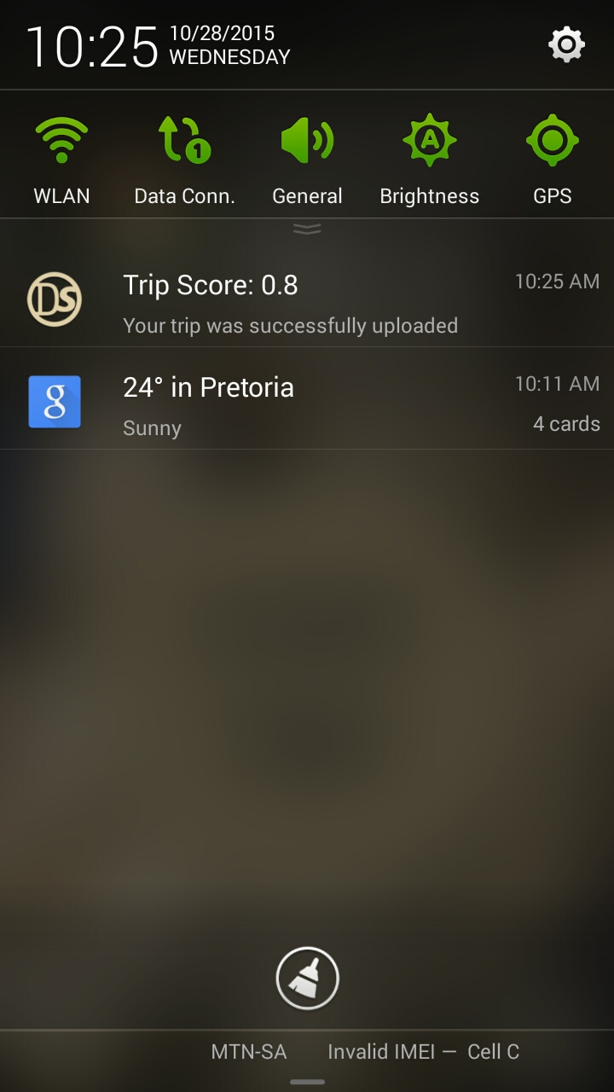

### Settings

Touching the icon will bring up the settings screen.

Wifi Only: A toggle button that if active will wait to upload all results until an active internet connection via Wi-Fi is detected.

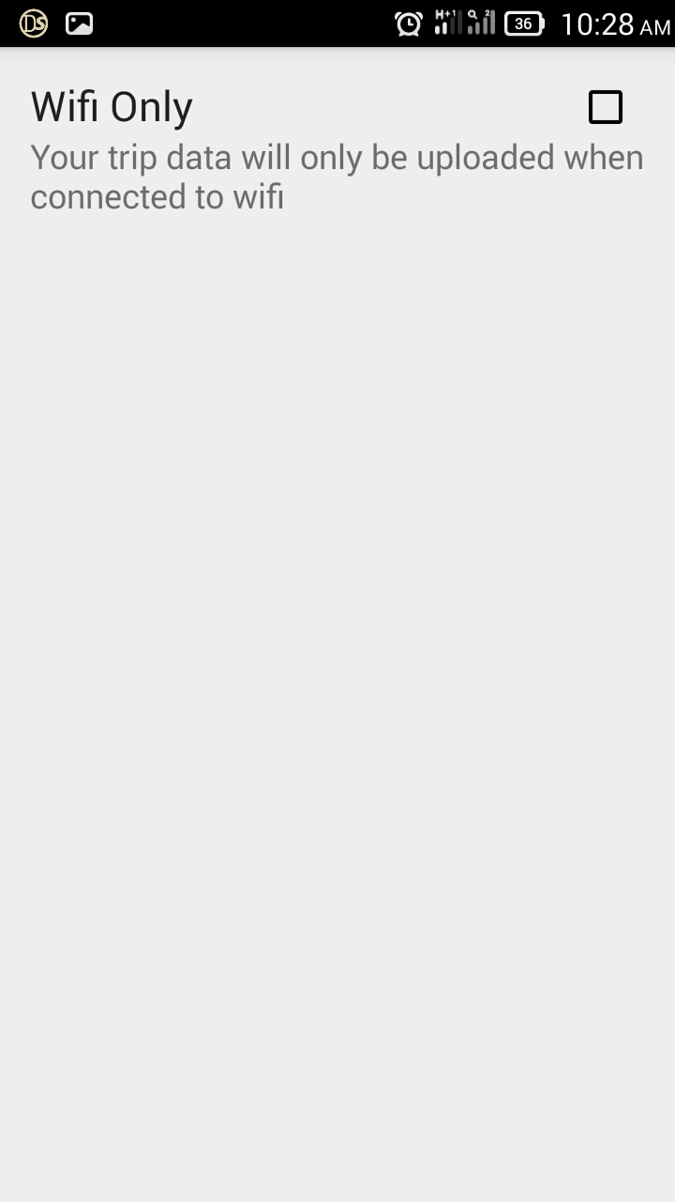

### View profile

Touching the icon will bring up the profile screen. Here the average score, total number of trips and Google+ information on the user can be viewed.



### View history

Touching the icon will bring up the trip history screen. Here the previous taken trips can be viewed including the score received, and time and date that the trip started.

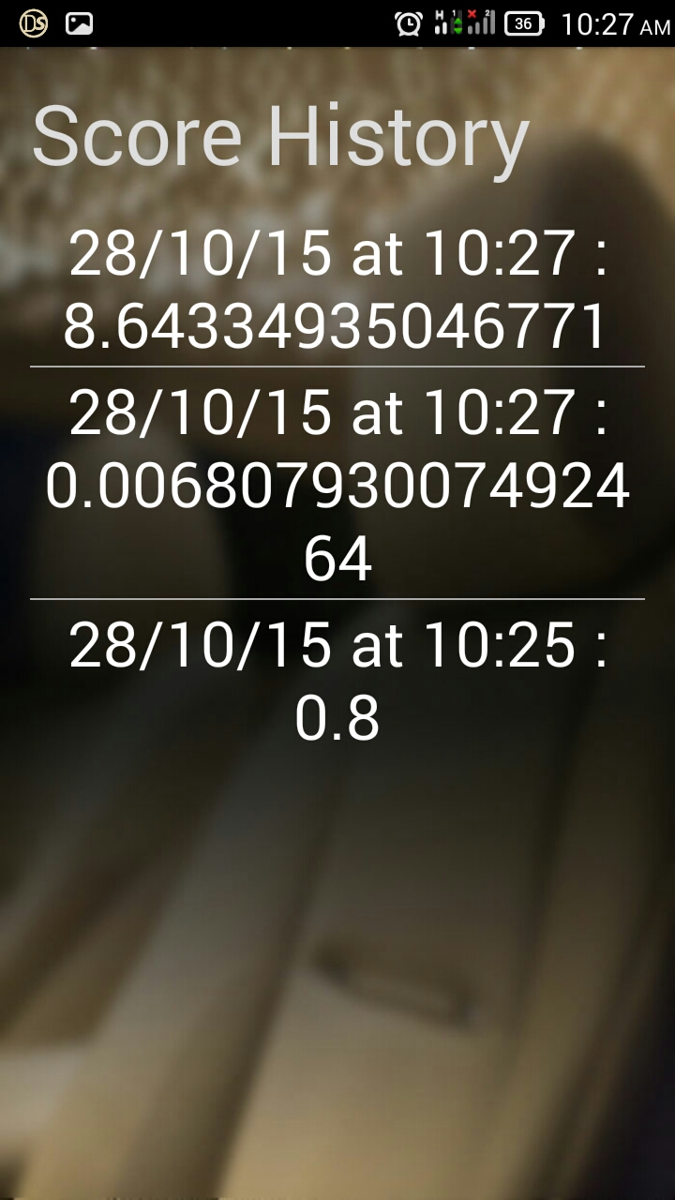

# Troubleshooting

## Common Problems

|  |  |
| --- | --- |
| **Problem** | **Solution** |
| I always obtain a bad score no matter how I drive. | It is possible that the device’s sensors are damaged and returning false readings. Contact your manufacturer for repairs.  Always ensure the device is mounted correctly so it can’t slide around. |
| I was speeding but I still obtained a very good score. | Ensure that the device has a GPS lock before moving. |
| I went on a trip and stopped the recording after my trip but I am not getting a score. | The device may not have had a stable internet connection to upload the data. Big trips can also take a while to upload but if nothing happens after 5 hours contact the developers for support. |
| The application crashes after I open it. | Always use the latest version of Drivestats as it is released. If the problem persists contact the developers for support. |

## Contact the Developers

Zander John Boshoff u12035671@tuks.co.za

Nicholas Thomas Robinson u12026442@tuks.co.za

# Additional Information

## List of countries currently supported by the DVT DriveStats application

* South Africa

## Supported Languages

* English (European)

1. For further information on Google Play Certification please contact the list of certified devices provided by https://support.google.com/googleplay/answer/1727131?hl=en.
2. Needed to maintain accurate readings throughout the trip.
3. For detailed information on how to enable third party applications, see <http://www.android.pk/blog/tutorials/how-to-enable-third-party-apps-installation-on-android-phones/>